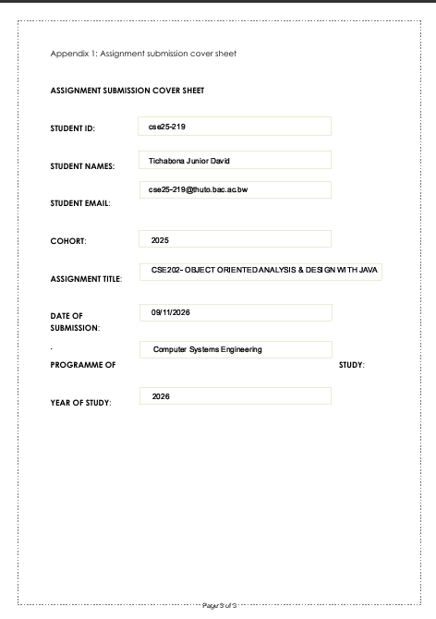
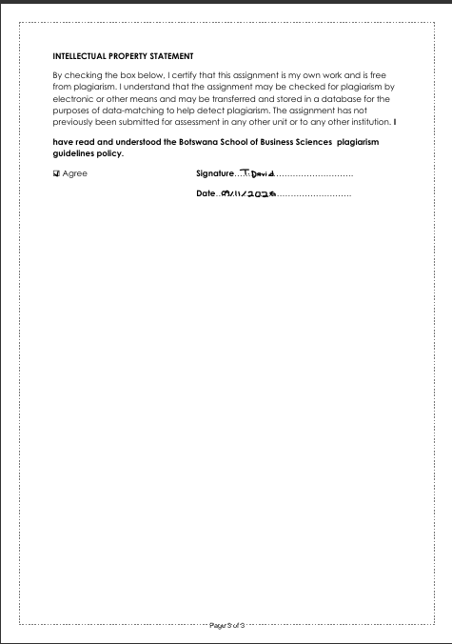

OOAD ASSIGNMENT
PART A
Github link- https://github.com/TichabonaDavid/OOAD-Assignment-2026
Functional Requirements
# | Functional Requirements
FR 1 | -the system shall allow a registered customer to open a savings account.
FR 2 | -the system shall allow a customer to open an investment account only if the deposit is at least P500.
FR 3 | -the system shall allow a customer to open a cheque account only if they are employed.
FR 4 | -the system must be able register a new customer.
FR 5 | -the system must allow a customer to make a deposit into any or all the accounts they hold.
FR 6 | -the system must pay an interest of 5% per month to the Investment Account and an interest of 0.05% per month for the Savings Account.
FR 7 | -the system must allow a registered customers to login.
FR 8 | -the system must record deposits, withdrawals and interest payments that took place in each account.
FR 9 | -the system shall require a customer to login before carrying out any function.
FR 10 | -the system shall allow the customer to withdraw from the investment and cheque accounts.

Non-Functional Requirements
# | Non-Functional Requirements | Type
NFR 1 | -deposits, withdrawals and balance enquiries should be complete within few seconds. | Performance
NFR 2 | -the system shall provide a simple user interface. | Usability
NFR 3 | -passwords must be stored securely and authentication should be needed if a customer wants to access account information. | Security
NFR 4 | -The system shall operate on Windows and macOS | Compatibility
NFR 5 | -in case of a failed transaction, the customers balance should not be in an incorrect state. | Reliability

INTERVIEW RECORD
Project: Banking System
Interviewer: Tichabona David
Date: 19 September
Q1: What types of accounts does the back offer, and what are the rules for opening them?
A: We offer 3 types of accounts:
1. Savings Account: Anyone can open this account. It is meant for saving, so customers deposit money but are not allowed to withdraw.
2. Investment Account: To open this account, a customer must first deposit a minimum of P500.
3. Cheque Account: This is an account for people who are employed. A customer needs to provide their employment details for them to open this account.
Q2: What type transactions can customers carryout in these accounts?
A: Customers must be able to deposit into any or all of the accounts. They must also be able to withdraw from the investment account and the cheque account.
Q3: How does the bank handle interest on these accounts?
A: The system must automatically calculate and pay interest. The Investment Account earns 5% per month and the Savings Account earns 0.05% per month.
Q4: How do we keep record of all these transactions?
A: The system must automatically keep a record of every deposit, withdrawal and interest payment that takes place in the account.
Q5: How fast should the system respond, and what kind of user interface do you expect?
A: The system should be fast. Deposits, withdrawals, and balance enquiries should complete within a few seconds. Also, the user interface must be simple and easy to use.
Q6: What happens if a transaction is not successful, and what operating system should the system run?
A: If a transaction fails the customers balance should not be left in an incorrect state. The system should be compatible with both Windows and macOS.
Q7: How should the system handle security and access?”
A: Customers must login with their username and passwords before carrying out any function. Passwords are stored securely, and authentication is required.
Structural UML Modelling
Use Case Diagram
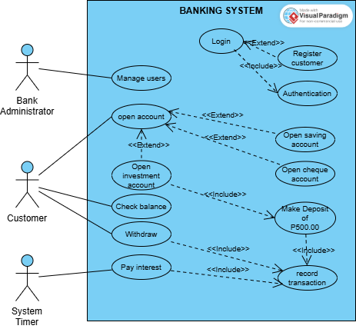
UseCase Descriptions
Actor | Usecase
Bank Administrator | -Manage Users
Customer | -Open account  -Check Balance  -Withdraw
System Timer | -Pay Interest

Class Diagram
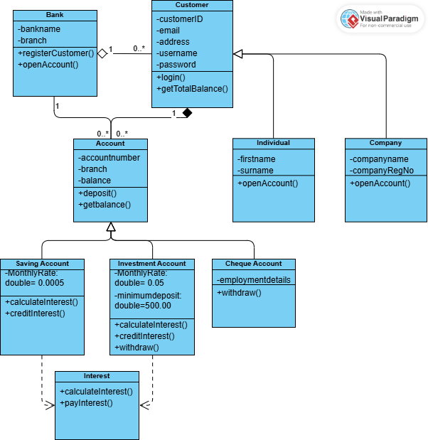

Class Description
CLASS | DESCRIPTION
Bank | -It registers customers and opens an account for them.
Customer | -Holds personal data such as CustomerID, email, address, usernames and passwords. Has operations login() and getTotalBalance().
Account | -It is an abstract. It holds the attributes and behaviour of all accounts. It has the accountnumber, branch and balance. It has methods deposit() and getBalance().
Individual | -It extends Customer class, it implements openAccount()
Company | -It extends Customer class, it implements openAccount()
Savings Account | -It extends the Account class, it implements calculateInterest() and creditInterest().
Investment Account | -It extends the Account class, it implements calculateInterest(), creditInterest() and withdraw().
Cheque Account | -It extends the Account class, it implements withdraw()
Interest | -Contact for accounts that earn interest.

3. Behavioural UML Modelling
SEQUENCE DIAGRAMS
A) Login Sequence Diagram
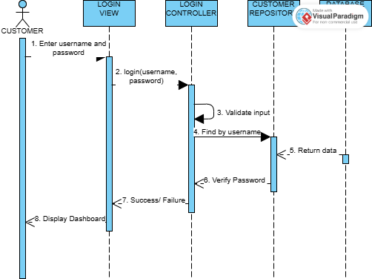

B) Deposit Sequence Diagram
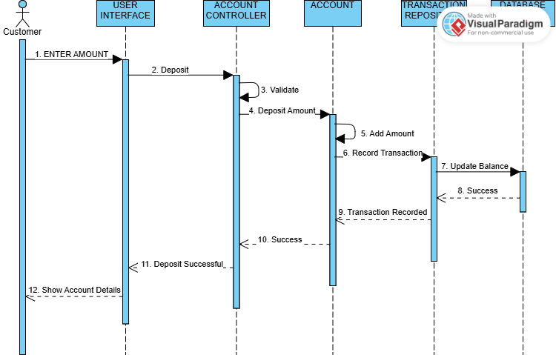

STATE DIAGRAM


